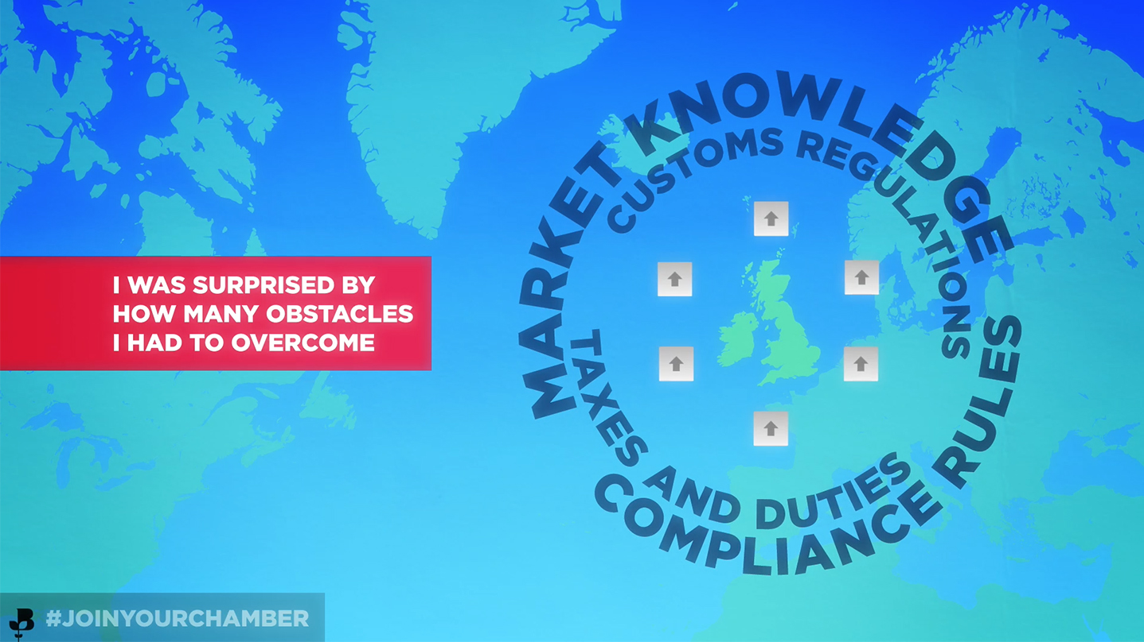

Fife Chamber of Commerce is delighted to launch their new International Trade Courses which are part of a British Chambers of Commerce National Training Programme for exporters.
Delegates will have the opportunity to complete a test paper at the end the course which is marked externally and the candidate will receive a BCC accredited certificate. If you choose to complete all 5 courses you will gain a Foundation Award in International Trade.
These courses are mapped to Level 2 NVQ terminology and provide invaluable basic skills for small and large companies alike.
You can choose to attend any of the courses or indeed all of them!
19th October - Understanding Exporting (full day)
Learning outcomes:
- Be able to prepare an export quotation
- Be able to organise the export office
- Understand export order processing and an overview of export documentation and terms of sale
3rd November - Incoterms (half day)
Learning outcomes:
- Be able to understand why INCOTERMS were created and their purpose.
- Be able to understand the definitions of the INCOTERMS 2010 rules.
- Be able to identify the parties involved in INOTERMS, their roles and responsibilities.
- Be able to understand the benefits of INCOTERMS.
- Be able to identify where to go for help and information on INCOTERMS.
2nd December - Export Documentation (full day)
Learning outcomes:
- Be able to understand how to produce the necessary documentation for an international shipment
- Be able to identify where to go for sources of international information and assistance
- Be able to identify modes of transport
26th January - Methods of Payment including Letters of Credit (full day)
Learning outcomes:
- Be able to identify the different methods of payment used in international trade.
- Be able to identify and understand the necessary documentation for payment.
- Be able to comply with the requirements of different methods of payment.
- Be able to identify the L/C procedure and identify the parties to an L/C
- Be able to identify the different methods of payment and the different types of Letters of Credit
- Be able to comply with the requirements of the Letter of Credit
23rd February - Import Procedures (full day)
Learning outcomes:
- Be able to demonstrate an understanding of import documentation and procedures
- Be able to identify where to go for sources of international information and assistance
- Be able to comply with customs procedures

Each course takes place at our offices in John Smith Business Park, Kirkcaldy and lunch is included with full day courses.

Members rates* - full day £100+VAT / half day £60+VAT
Non-Members rates – full day £150+VAT / half day £90+VAT

Book online through the Members Portal or contact a member of the team on 01592 647740 info@fifechamber.co.uk

Supported by the Fife Economy Partnership

*Members of Dundee & Angus Chamber and Perthshire Chamber can attend at member rates.

